**Aryan Rathee**

**190123013**

**MA323 Endsem Lab Report**

1.

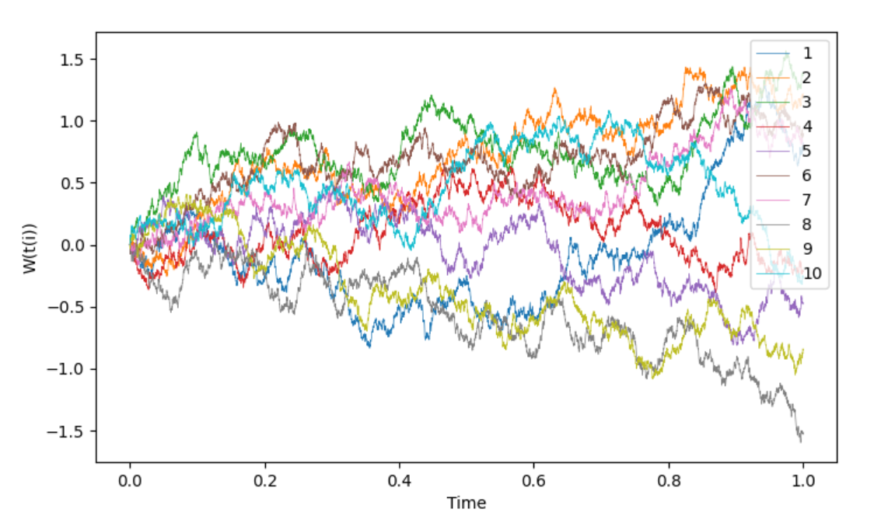

The above formula is used to compute the sample paths of the all the browian motions where W(t(i)) is the value of the Brownian path at time t(i). The interval is [0,1] i.e. 1 sec and we have to generate 5000 points of the path so for that purpose we take the points at time interval 1/5000. Also, it is given that W(0) is 0 and after that we use the previous value generated to generate the next value of the Brownian path. The Z(i) are random variable with standard normal distribution, N(0,1) i.e. with mean 0 and standard deviation 1, which are calculated using Box-Muller method.

When it comes for plotting graph, for that I first generate all values and store them in a 2D array, also I make another array for the time intervals, then I plot all the graphs using matplot library in python, all one by one on the same graph, then I display the graph which shows a completely random motion of paths whose final values range all the way from -1.5 to 1.5 all starting from 0.

2.

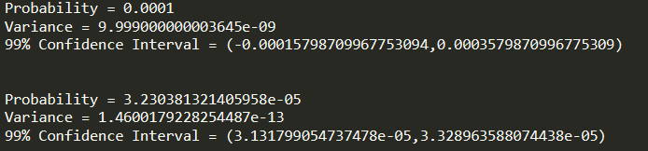

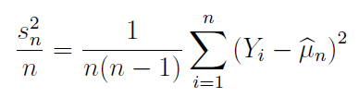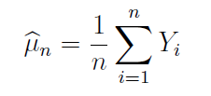

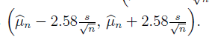

a. First random variables are generated using Box-Muller method which have standard normal distribution, then I checked if they are greater than 4 or not, if yes then I append 1 in the array other wise 0, after the computation of random variables is complete, then the probability of X>4 will be equal to the expectation(mean) of the numbers and then variance is calculated using the above formula and for 99% confidence interval, we use the above formula, for that we need mean, variance and n(no. of sample points), all of which we have. The confidence interval obtained is shown in the above figure.

b. Here the importance distribution is taken as q=e^(-x+4), whenever x>4 and whenever x is less than 4, then q is 0, the corresponding CDF is 1-e^(-x+4) and for generating the random number with this distribution we have to find its inverse and then use it, which comes out to be 4-log(1-u) which has the same distribution as 4-log(u) where u has uniform distribution in (0,1). This pdf is chosen because it is 0 when x<=4 and hence generates only the values of x greater than 4 and so decreases the space of our search where it is almost certain that we are not going to get our desired value. The likelihood ratio, p(x)/q(x) comes out to e^(-x*x/2+x-4)/sqrt(2*pi) which is used to generate the sampling and the distribution of x is that of q. In this case also the confidence interval is then calculated in the same way and the obtained value is denoted in the above figure.

c. The variance in part b is drastically decreased from part a, almost by a factor of 10^(-4), this is because we are now considering less points which are not of out use, now we consider those points which increase our sample space, also this increase in sqrt(variance) is directly related to the confidence interval and so we get a smaller confidence interval in the part b which is good thing.

3.

In this question first we will integrate the function w.r.t y with the limits -infinity to +infinity and then it will become single variable function, then we use standard monte carlo technique to generate random points and calculate expectation.

The function comes out to be (9/8)*log(1+x)*exp((-3/2)*x).